TYBSc CS 2020-2021 USCS607:Wireless Sensor Network

RollNo: 18043 Date: 03/02/2021

**Practical No. 1**

**Aim: Understanding the Sensor Node Hardware. (For Eg. Sensors, Nodes(Sensor mote), Base Station, Graphical User Interface.)**

**Wireless Sensor Network Components:**

A wireless sensor network (WSN) is a hardware and software package that typically consists of four parts (see Figure 1):

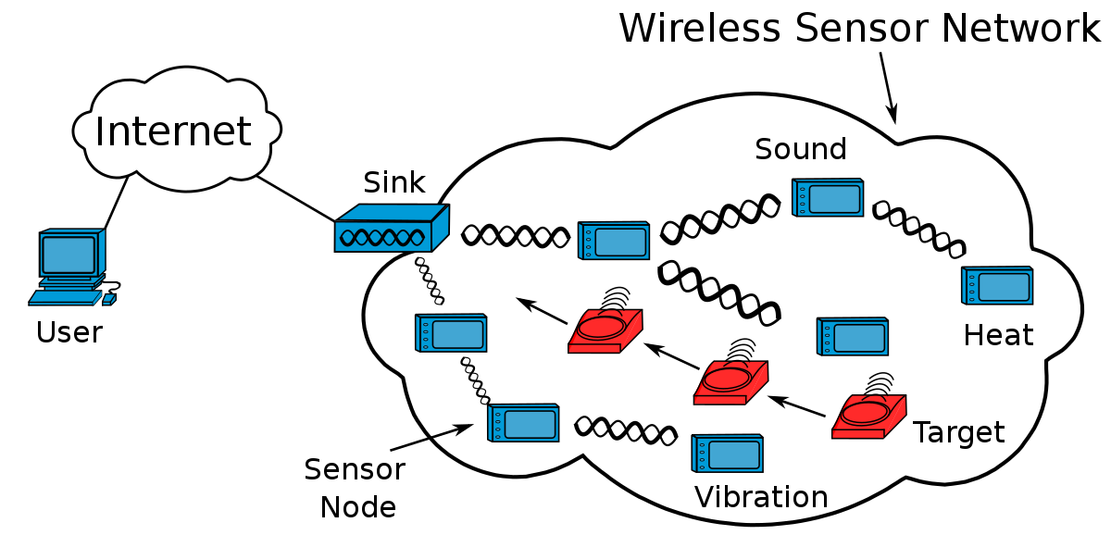

* **Sensors**
* **Nodes**
* **Base Station**
* **Graphical User Interface**

**Sensors:**

* ‘Sensors’ connected to each node by a wired connection. In our case, we use sensors that can measure soil moisture, electrical conductivity, soil temperature, water pressure, flow rate, or a range of weather variables.
* Typically, a wireless sensor network contains hundreds of thousands of sensor nodes. The sensor nodes can communicate among themselves using radio signals.
* A wireless sensor node is equipped with sensing and computing devices, radio transceivers and power components.
* Sensors in WSN are used to capture the environmental variables and which is used for data acquisition. Sensor signals are converted into electrical signals.

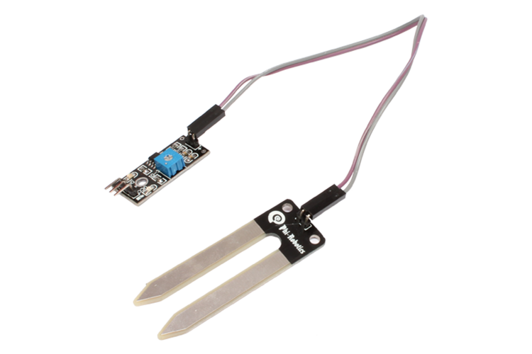

Fig.1 :Soil Moisture Sensor

**Nodes:**

* ‘Nodes’ collect the data from sensors and transmit that to a ‘base station’ computer using a one-way (in the case of monitoring) or two-­­way (in the case of monitoring and control) radio.
* Nodes can simply monitor environmental and soil conditions or can be used to make control decisions. For example, some nodes have the capability to control an electric valve, such as an irrigation valve.
* It is used to receive the data produced by the Sensors and sends it to the WLAN access point. It consists of a microcontroller, transceiver, external memory, and power source.
* This is a nR5 node (Decagon Devices, Pullman, WA) used as part of a wireless sensor network at McCorkle Nurseries (Dearing, GA).On the right side, there is a relay that can be used to open and close irrigation valves. The nodes transmit all collected data to a base station and computer using a radio.

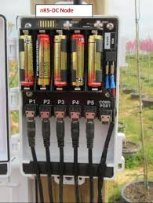

Fig. 2: nR5 node

**Base Station:**

* ‘Base Station’ computer connects the system to the internet, so that data collected by the nodes, then transmitted to the base station computer, can be viewed anywhere an internet connection is available.
* In radio communications, a base station is a wireless communications station installed at a fixed location and used to communicate as part of one of the following:
* A push-to-talk two-way radio system, or.
* A wireless telephone system such as cellular CDMA or GSM cell site.
* Terrestrial Trunked Radio.

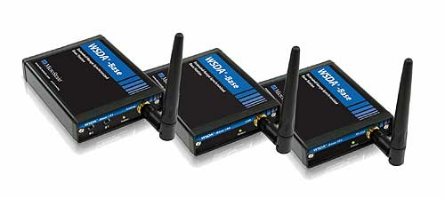

Fig.3 Wireless network base station WSDA -Base-101 LXRS

**Graphical User Interface:**

* ‘Graphical User Interface’ is the web-­­based software package, that allows the data collected by sensors to be viewed. The software is also used to set irrigation parameters.
* The graphical user interface is a form of user interface that allows users to interact with electronic devices through graphical icons and audio indicator such as primary notation, instead of text-based user interfaces, typed command labels or text navigation.
* The actions in a GUI are usually performed through direct manipulation of the graphical elements. Beyond computers, GUIs are used in many handheld mobile devices such as MP3 players, portable media players, gaming devices, smartphones and smaller household, office and industrial controls.

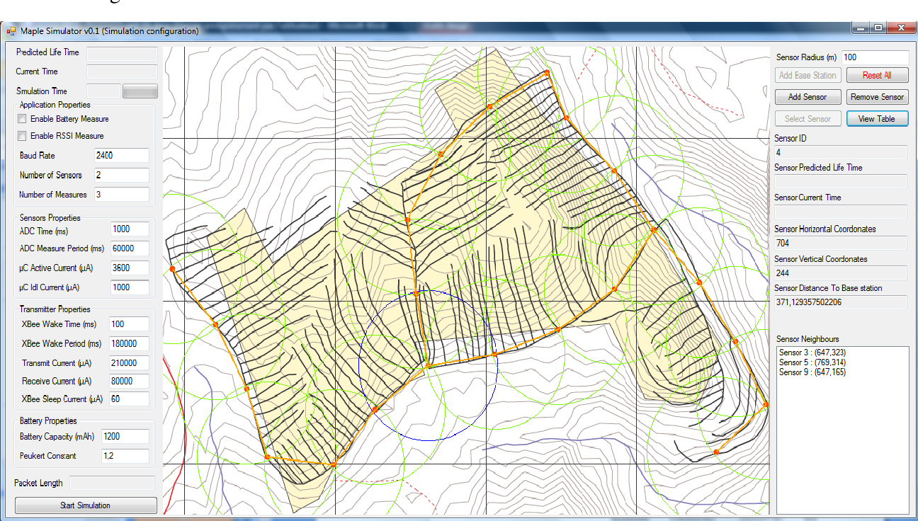

Fig. 4 . A GRAPHICAL USER INTERFACE SIMULATOR FOR WIRELESS SENSOR NETWORKS LIFETIME ESTIMATION

**Application:**

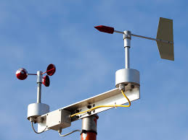

Fig.5.Typical **anemometer** monitoring sensors

* **Anemometer** - An anemometer measures how fast the wind is blowing, or wind speed. Weather stations track wind speed and display current wind speed (in MPH, KPH or knots) and record peak and average wind speed readings.
* A weather station is a device that collects data related to the weather and environment using many different sensors.
* Weather stations are also called weather centres, personal weather stations, professional weather stations, home weather stations, weather forecaster and forecasters.
* Weather stations include weather tools such as a **thermometer** to take temperature readings, a **barometer** to measure the pressure in the atmosphere, as well as other sensors to measure rain, wind, humidity, and more.